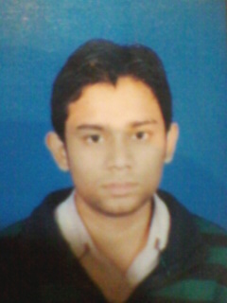
RESUME
JWALA KUMAR GUPTA
MOH-SHAMIR TAKYA NEAR TOP
P.O-CHAND CHOURA
DIST-GAYA (BIHAR) 823001
E-MAIL-johndavidse@gmail.com
MOB-9504811470
CAREER OBJECTIVE
As a determined person I am looking for a suitable & challenging career in a professional managed organization, where I can apply my education training & experience for growth and achievement and goals
PERSONALITY ATTBLQTES
- Determination & Adaptability
- Positive & Optimistic Attitude
- Energetic and result oriented
- Better communication skill
ACADEMIC QUALIFICATION
- BCA(Bachelor of Computer Application) from M.U Bodhgaya with 71%
- I.sc Passed from B.S.E.B, Patna in 2008 with 46%
- Matric passed from B.S.E.B, Patna in 2006 with 57%
ACHIEVEMENT
- Qualify the B.C.A Enterence test 2008.
- Qualify the Tech-Bravo Campus Selection 2011.
TECHNICAL SKILL
- Software : Operating system (OS), Windows XP
- MS-Office : MS Word, MS Excel, MS Acess
- Language : C,C++,Java VB
PERSONAL PROFILE
Name : JWALA KUMAR GUPTA
Father’s Name : DEEPAK KUMAR GUPTA
Language Known : Hindi & English
Date of Birth : 15th April, 1991
Height : 5’8”
Hobbies : Cricket
DECLABATION
I HEREBY DECLARE THAT THE ABOVE INFORMATION IS TRUE TO THE BEST OF MY KNOWLELDGE AND BELIVE.

Date 04/02/2012
Place: gaya.

